Shandong University of Technology

Assignment Report

Course Name： Computer Science
College ： Shan Dong University of Technology
Course ： Software Testing and Inspection
Name ： Haolong Qi, Xiaozhou Liu
ID ： 22110543060, 22110543053

2024 .11.1

Assignment 2 Part 2 Report Page 1
Team mates name and ID: Haolong Qi齐浩龙22110543060, Xiaozhou Liu刘孝宙 22110543053 Score:
Course name: Software Testing and Inspection
Project Code | 210518136 | Course Instructor | Ming Zhu
Purpose | Structural Testing.
equipment | PC, windows, C, Java
1. Objective
In this assignment, you will use JUnit to perform the functional tests.

2. Assignment Description

Q3. You need to implement programs that can generate test cases for the functions in Q1 and Q2 respectively, according to Boundary Value Analysis, Robustness Testing, Worst-Case, and Robust Worst Case and Strong Normal Equivalence Class Testing and Strong Robust Equivalence Class Testing criteria.

Q4. You need to use the generated test cases in Q3 to test your programs in Q1 and Q2.

3. Test Report
Ⅰ. Description of Project
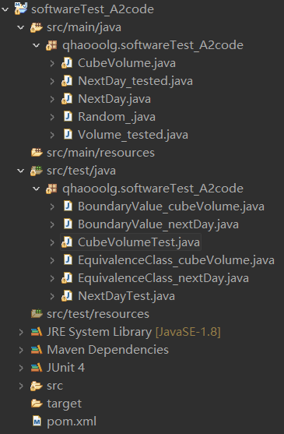
Project Structure:

Idea of Test:
We take the @ParameterizedTest of junit5 and transfers parameters to the method through @MethodSource, to make the test class as structured as possible.

Progress:
- Dividing the method generating expected output and method tested into two different class, instantiating them in test class.
private NextDay_tested test = new NextDay_tested(); //测试函数 method received should be tested
private NextDay expected = new NextDay(); //期望值函数 written by myself

- Write a class called Random_ to generate test case randomly.
//in NextDayTest class
static private Random_ num = new Random_(); //基于输入数据的范围随机生成测试用例

public class Random_ {
Random num;

//generate a number which range is [min, max)
public int random(int min, int max) {
int seed = Integer.parseInt(String.format("%tN", new Date()));
num = new Random(seed);
return min + num.nextInt(max - min);
}
}

- Create six @ParameterizedTest test methods equipped with @MethodSource, and create appropriate generatingParamsMethod typed as Stream<Arguments>. Test method only uses assertEquals to compare the expected output and actual output with junit5.
@ParameterizedTest
@MethodSource("BoundaryValueAnalysis_params")
public synchronized void testInterface_BoundaryValueAnalysis(int y, int m, int d){ //各类数据测试接口
System.out.println("(Boundary Value Analysis)");
String s = "[Input Data] Year: " + y + ", Month: " + m + ", Day: " + d;
System.out.println(s);
assertEquals("[WRONG INFORMATION] Data tested mismatching the expected data",
expected.nextDay(y, m, d),
test.nextDay(y, m, d));
}
static synchronized Stream<Arguments> BoundaryValueAnalysis_params() throws InterruptedException{
bv.initialization_BoundaryValueAnalysis_params();
List<Arguments> arglist = new ArrayList<>();

arglist.add(Arguments.of(bv.y_nom(), bv.m_nom(), bv.d_nom()));
for(int i=0; i<bv.y.size(); i++) {
int y = bv.y.get(i);
arglist.add(Arguments.of(y, bv.m_nom(), bv.d_nom()));
Thread.sleep(1);
//每生成一个测试样例需要进行短时停滞，以避免程序运行过快导致其中几组测试样例的随机生成器所应用的系统时间种子无差别，从而没有达到真随机效果
}
for(int i=0; i<bv.m.size(); i++) {
int m = bv.m.get(i);
arglist.add(Arguments.of(bv.y_nom(), m, bv.d_nom()));
Thread.sleep(1);
}
for(int i=0; i<bv.d.size(); i++) {
int d = bv.d.get(i);
arglist.add(Arguments.of(bv.y_nom(), bv.m_nom(), d));
Thread.sleep(1);
}
return arglist.stream();
}

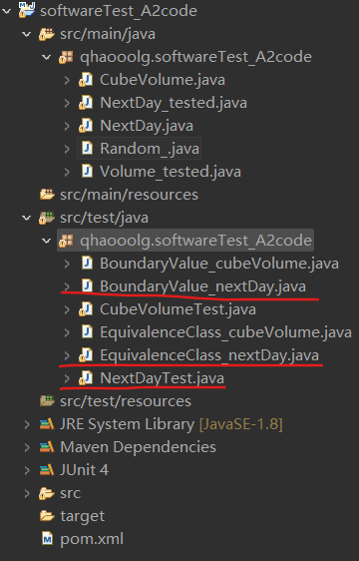
- As mentioned above, the parameters used in the generatingParamsMethod is missing now, so it’s supposed to create a class that it reaches the task of data set collection. Then create this class called DataSpecies_Method and put it in the package with the test class.
//example (data collection of Equivalence Class Testing)
public class EquivalenceClass_nextDay {
Random_ num = new Random_(); //generate a number which range is [min, max)
NextDay nextday = new NextDay();

int[] m1 = {4, 6, 9, 11};
int[] m2 = {1, 3, 5, 7, 8, 10, 12};
static ArrayList<Integer> y, m, d;

protected int y1() throws InterruptedException {
int y = num.random(1812, 2013);
while(!nextday.isLeapYear(y)) {
y = num.random(1812, 2013);
Thread.sleep(1);
}
return y;
}

protected int y2() throws InterruptedException {
int y = num.random(1812, 2013);
while(nextday.isLeapYear(y)) {
y = num.random(1812, 2013);
Thread.sleep(1);
}
return y;
}

protected int y3() {
int y = num.random(0, 1812);
return y;
}

protected int y4() {
int y = num.random(2013, 3001);
return y;
}

protected void initialization_StrongNormalEquivalenceClassTesting_params() throws InterruptedException {
y = new ArrayList<>();
m = new ArrayList<>();
d = new ArrayList<>();
y.add(this.y1());
y.add(this.y2());
m.add(this.m1());
m.add(this.m2());
m.add(this.m3());
d.add(this.d1());
d.add(this.d2());
d.add(this.d3());
d.add(this.d4());
}
}

- After all the test method finished, run this test class in one time, check the report of JUnit in eclipse. All the test cases are listed in the JUnit column, it’s convenient to check whether a test case exists the situation that actual output mismatching expected output.
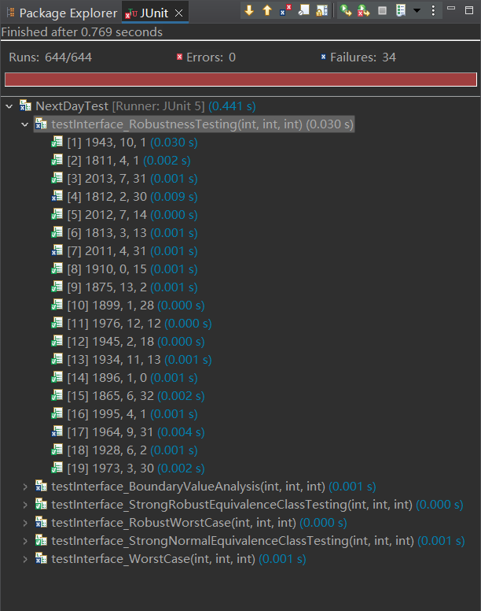
comparison of expected output and actual output
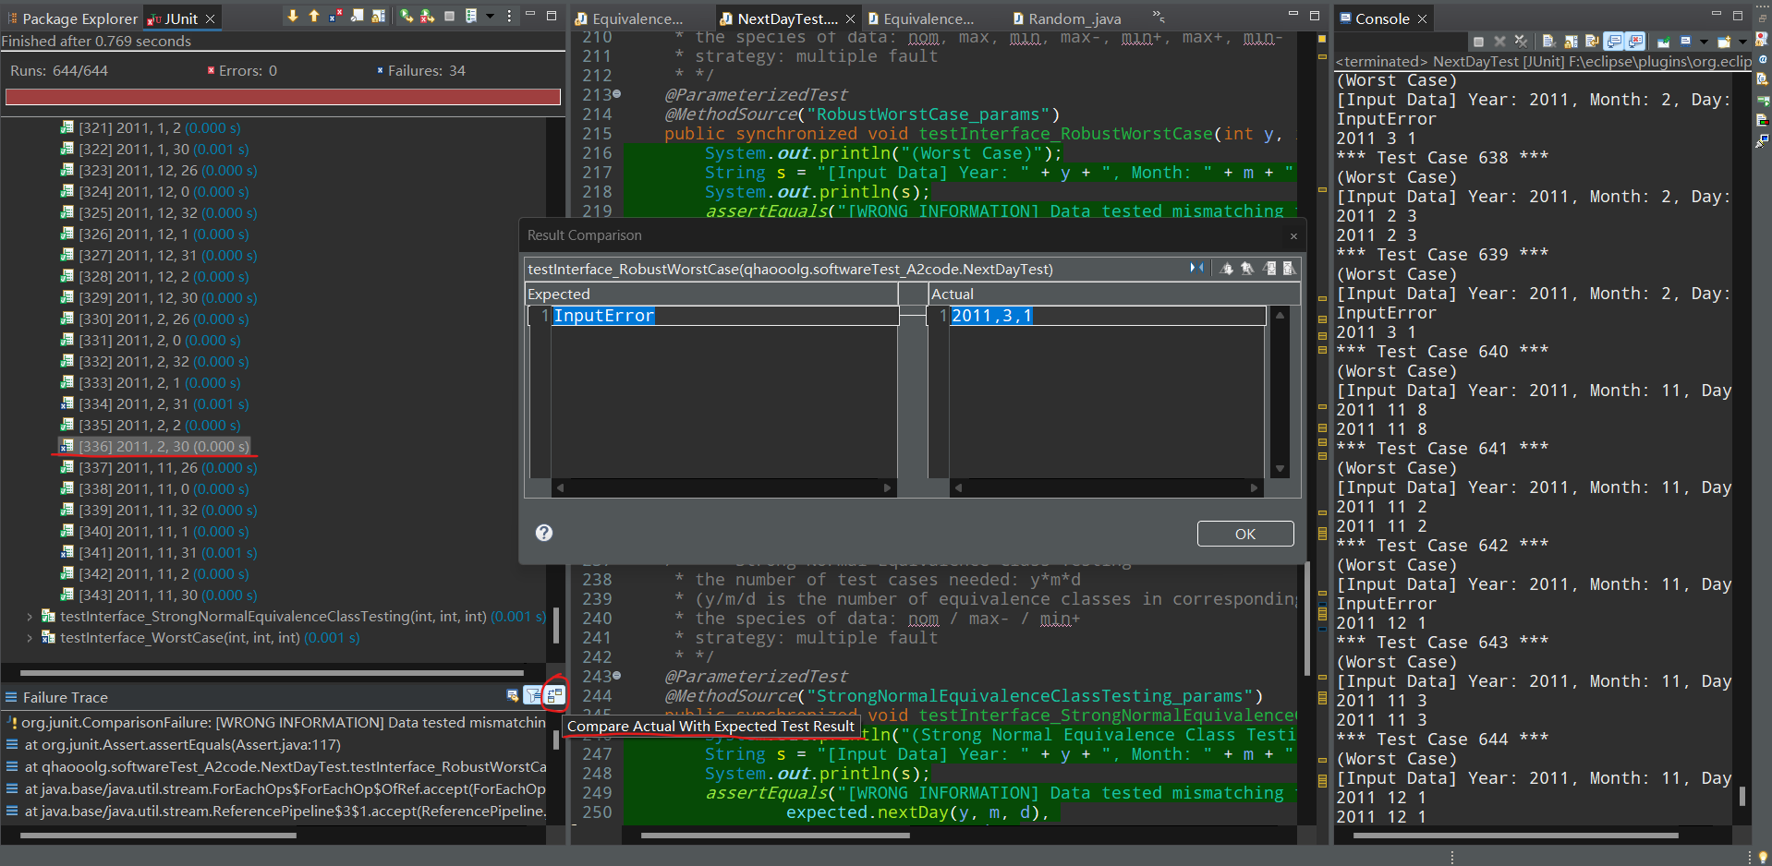

- Finally, according to the report of JUnit, we can analysis it and get the bug even its location in code quickly and precisely, and then, generate a personal report of that.

Ⅱ. Innovations
- Realize the encapsulation characteristic. Put the test class and data collection class apart, improve the reusability and robustness of code.
static private EquivalenceClass_nextDay ec = new EquivalenceClass_nextDay();
static Stream<Arguments> StrongRobustEquivalenceClassTesting_params() throws InterruptedException{
ec.initialization_StrongRobustEquivalenceClassTesting_params();
List<Arguments> arglist = new ArrayList<>();

for(int i=0; i<ec.y.size(); i++)
for(int j=0; j<ec.m.size(); j++)
for(int k=0; k<ec.d.size(); k++)
arglist.add(Arguments.of(ec.y.get(i), ec.m.get(j), ec.d.get(k)) );

return arglist.stream();
}

static ArrayList<Integer> y, m, d;
protected void initialization_StrongRobustEquivalenceClassTesting_params() throws InterruptedException{
y = new ArrayList<>();
m = new ArrayList<>();
d = new ArrayList<>();
y.add(this.y1());
y.add(this.y2());
y.add(this.y3());
y.add(this.y4());
m.add(this.m1());
m.add(this.m2());
m.add(this.m3());
m.add(this.m4());
m.add(this.m5());
d.add(this.d1());
d.add(this.d2());
d.add(this.d3());
d.add(this.d4());
d.add(this.d5());
d.add(this.d6());
}

- Stick to printing information in console, in order to prevent something going wrong in JUnit plugin. Or get other information which is not displayed in JUnit plugin.
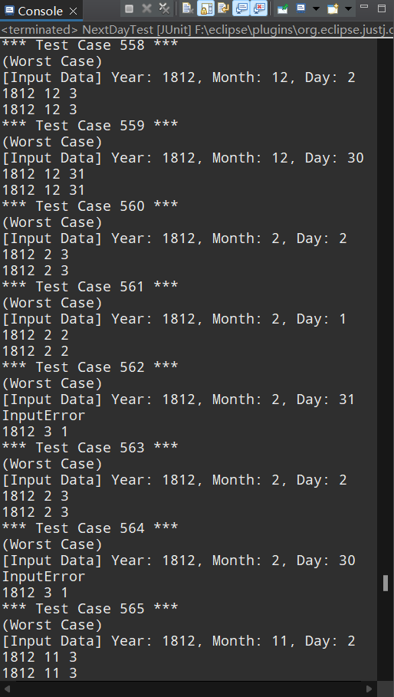
- Using @ParameterizedTest and transferring the parameters through static data stream. It allows programmer to realize parameter transformation in most curious environments.
- Realize the function which is similar to test suite. With using static data stream to transfer parameter, it’s easy to occur thread conflict between methods generating parameters. We put the input data set out of the test class instead of embedding it in parameter collection class, together with the initialization of parameters. Just leaving the usage of initialization in test class. That makes running all test cases in one class feasible.
- Generating test case dynamically with truly random rule. Writing a Random_ class to generate a number between parameter min and parameter max input. The class using system timestamp as the seed of instantiating java.util.Random object. Therefore, it’s almost various for each running of test class.

Ⅲ. Analysis of Data
(all the data displayed of a test class is run in one time, selected from Test Run History)
a. nextDay()
Equivalence Class Partitioning:
* To unify the default invalid data criteria, the range of invalid data is displayed as followed:
* y_overMin(y3)->[0, 1811] y_overMax(y4)->[2013, 3000]
* m_overMin(m4)->[-100, 0] m_overMax(m5)->[13, 100]
* d_overMin(d5)->[-100, 0] m_overMax(d6)->[32, 100]
*
* Equivalence Class Partitioning:
* y1 = {year: 1812...2012 | leap_year(year)}
* y2 = {year: 1812...2012 | common_year(year)}
* m1 = {month: 1...12 | days(month) = 30} = {4, 6, 9, 11}
* m2 = {month: 1...12 | days(month) = 31} = {1, 3, 5, 7, 8, 10, 12}
* m3 = {2}
* d1 = {day: 1...28}
* d2 = {day: 1...29}
* d3 = {day: 1...30}
* d4 = {day: 1...31}

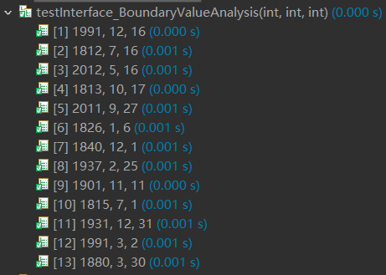
(1) Boundary Value Analysis

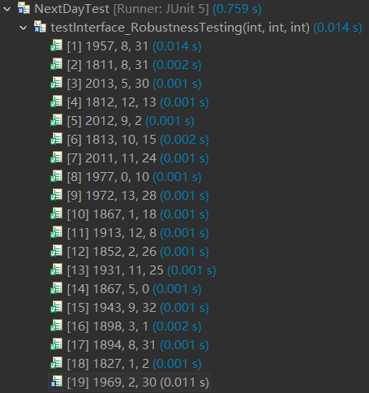
(2) Robustness Testing

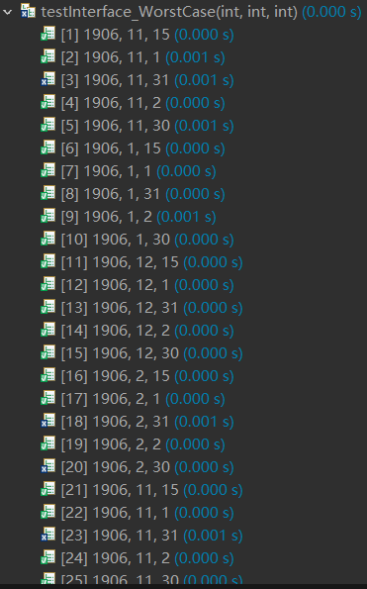
(3) Worst Case

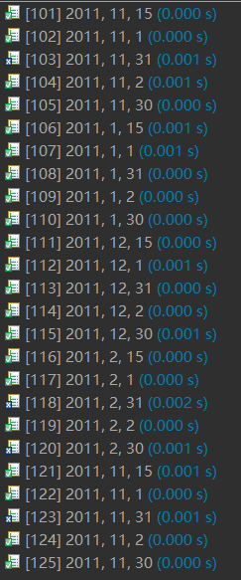
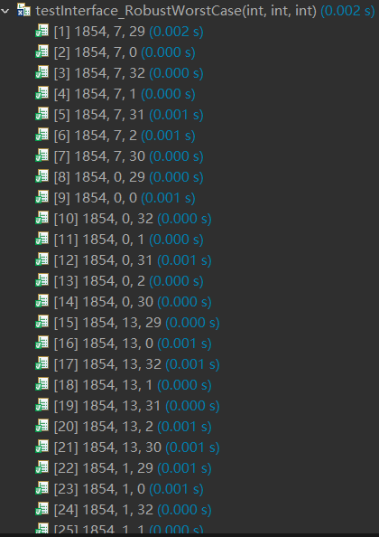
(4) Robust Worst Case
……

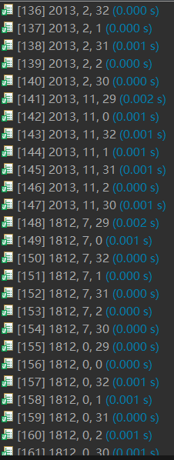
……
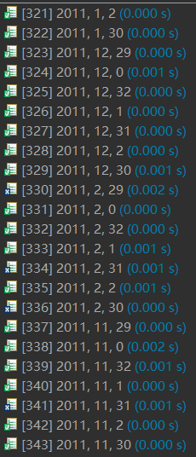

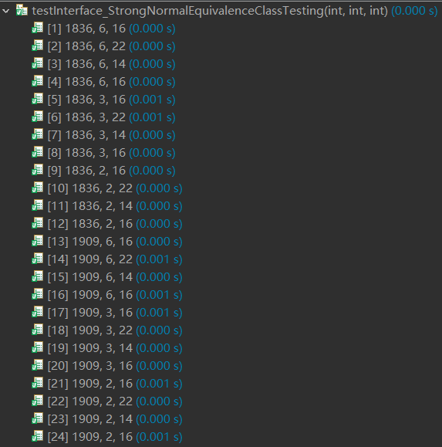
(5) Strong Normal Equivalence Class Testing

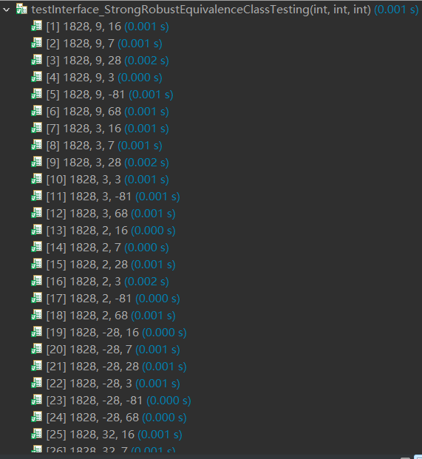
(6) Strong Robust Equivalence Class Testing
……
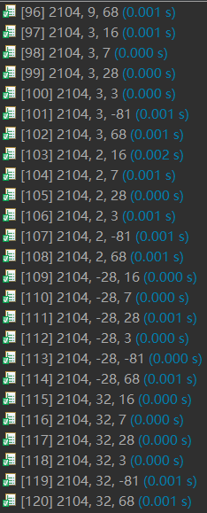
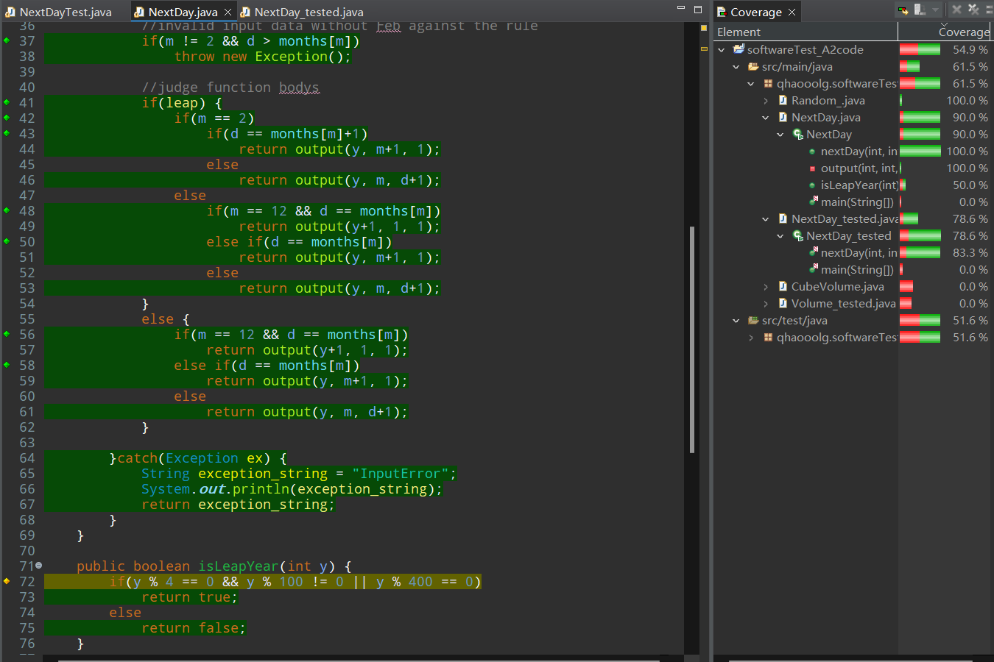
(7) Coverage for the test above
(run in 2024/11/16 10:21:39)
According to the graph of coverage, we can know that almost every code is run in this test. Because of the truly random mechanism, each run of the test class may cause different coverage result. For example:
[1] run in 2024/11/16 13:06:53
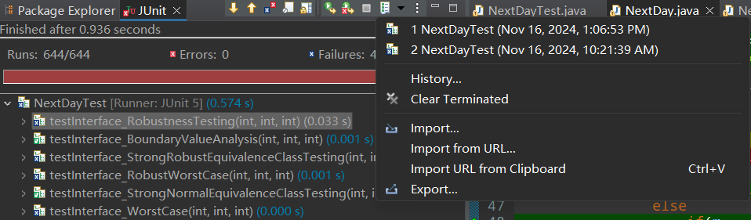
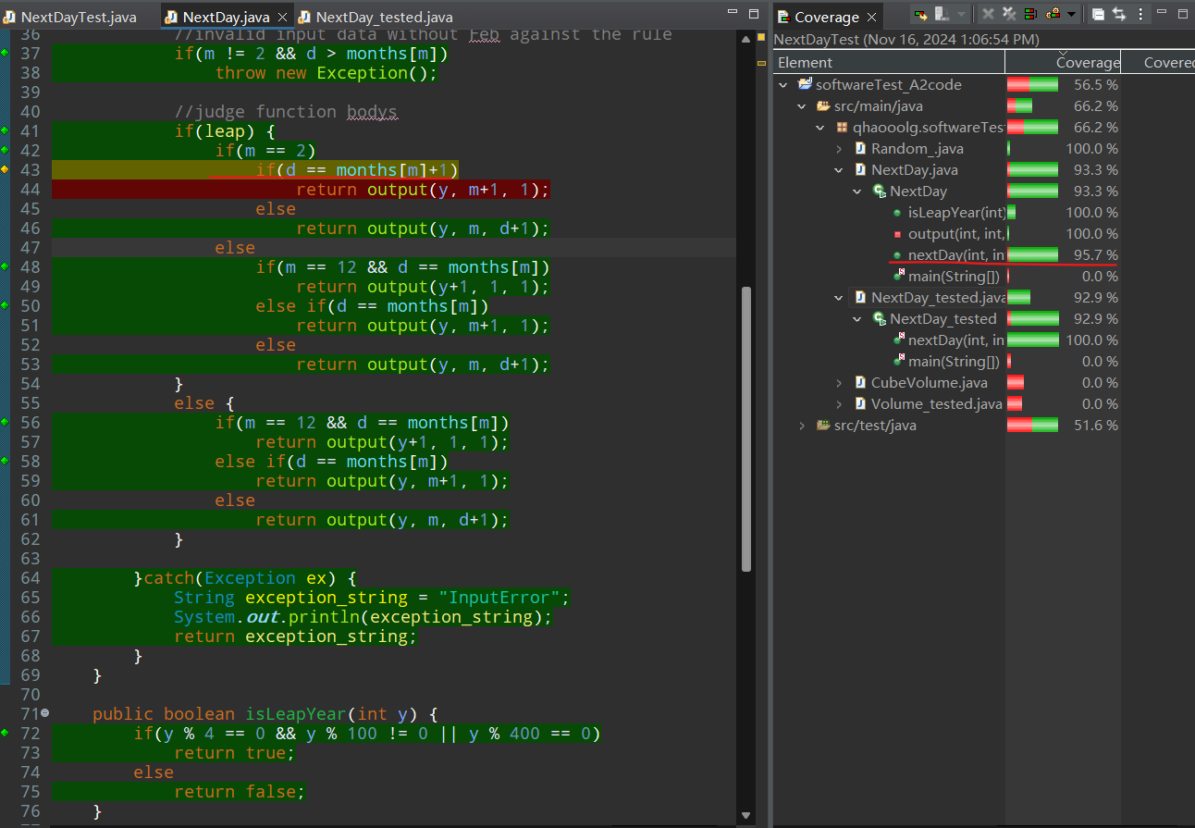

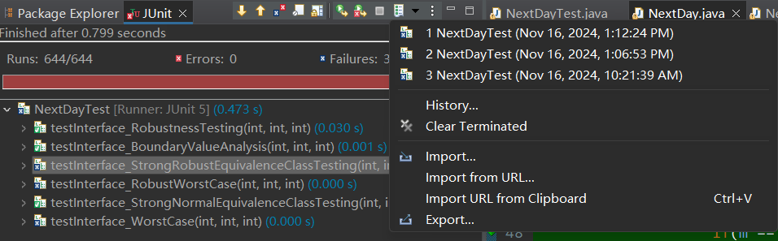
[2] run in 2024/11/16 13:12:24

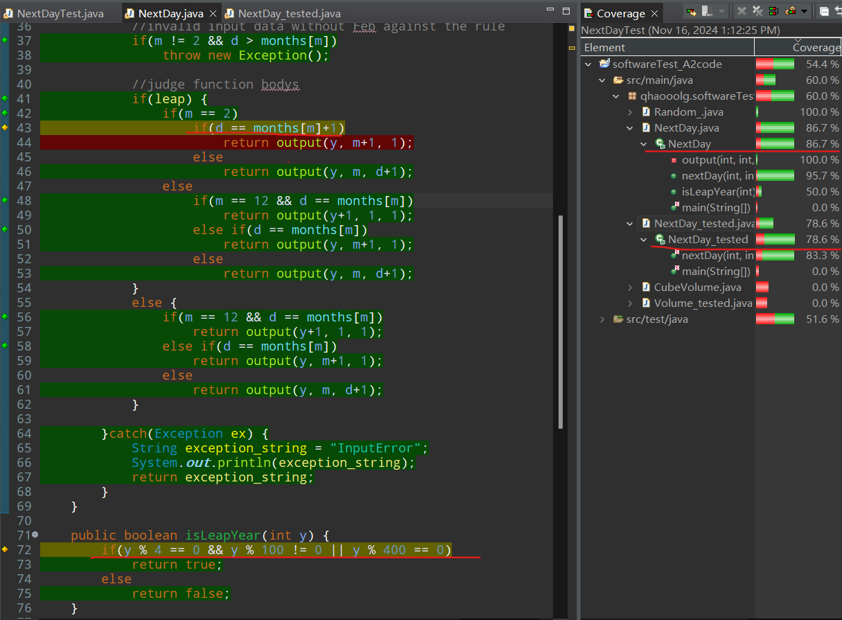
From the two example listed, we sum up that it’s supposed to run as more times as possible in order to improve the accuracy of test result.
(8) Result:
Based on the conclusion, there’s some representative test case to prove the method tested has fault. Test cases as followed:
Test Case | Input | Expected Output | Actual Output | Test Species
1 | 1815, 2, 30 | InputError | 1815, 3, 1 | Strong Robust Equivalence Class Testing
2 | 1881, 11, 31 | InputError | 1881, 12, 1 | Robust Worst Case
3 | 1812, 2, 31 | InputError | 1812, 3, 1 | Worst Case
(a test case may be used in over one test species)
According to the chart, we can estimate that method tested lacks the invalid boundary input judgement for Feb and months with 30 days.

b. CubeVolume()
Equivalence Class Partitioning:
* To unify the default invalid data criteria, the range of invalid data is displayed as followed:
* l_overMin(l2)->[-100, 1] l_overMax(l3)->[101, 200]
* w_overMin(w2)->[-100, 4] w_overMax(w3)->[201, 300]
* h_overMin(h2)->[-100, 19] h_overMax(h3)->[81, 200]
*
* Equivalence Class Partitioning:
* l1 = {length: 2...100}
* w1 = {width: 5...200}
* h1 = {height: 20...80}

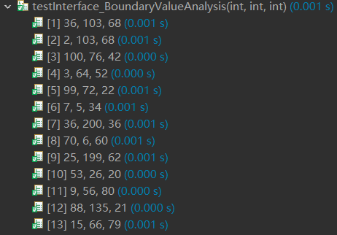
(1) Boundary Value Analysis

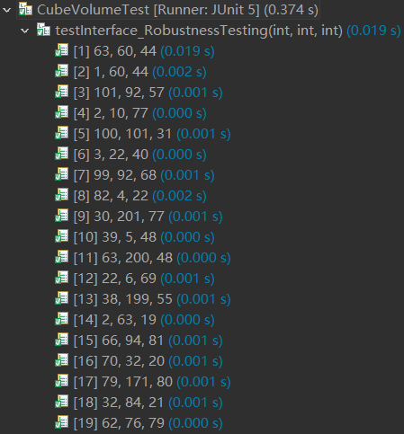
(2) Robustness Testing

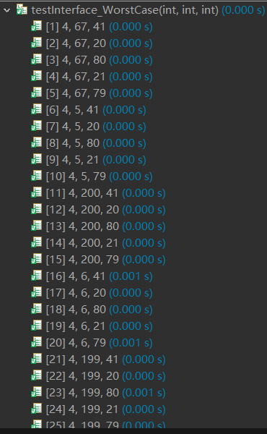
(3) Worst Case

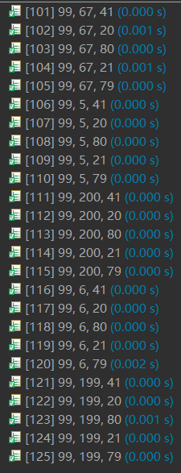

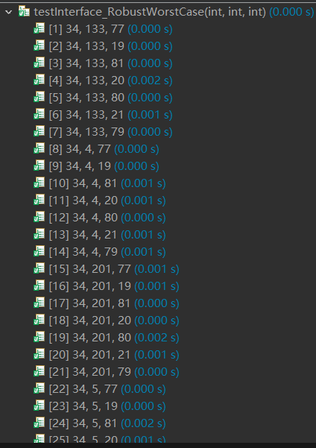
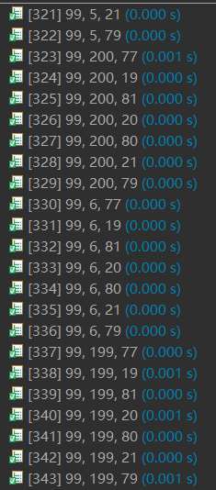
(4) Robust Worst Case

(5) Strong Normal Equivalence Class Testing
(6) Strong Robust Equivalence Class Testing
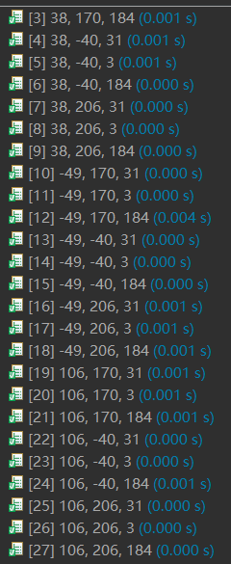
(7) Result:
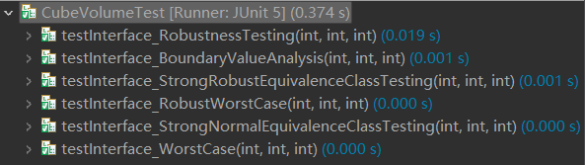
All the actual output matches expected output in six test species, so there’s no problem in tested method.

Ⅳ. Something other
Discussions:
While taking Equivalence Class Testing, the valid data set should consider the equivalence class partitioned by programmer. But sometimes, in one certain dimension, an equivalence class may be partitioned smaller than the max boundary of valid data which is allowed to input in this dimension. For example, in the method nextDay(int year, int month, int day), we all know that the common range of input parameter day is [1, 31], but it will be changed into [1, 28] while the input month is 2 without leap-year. And this range will be changed again while the input year is leap-year. So how could we judge the boundary of invalid data? Only based on the common invalid input, or take the special Feb and leap-year into account comprehensively?
Answer:
Input data only consider the valid input range. If the result is invalid then it depends on the calculate rule, and has no connection to the input data.

4. Deliverables:

Report: Write a technical report that includes your answers to questions 3 and 4. Note that in addition to the correctness of your answers, the structure and quality of the report itself will also be evaluated.

Source code with test cases: Export your Eclipse project (including the source code and your JUnit tests) as a zip file.

5. Submission:

Archive both deliverables into a single zip file.

Name of the lab：Computing Center 2024.10.22

